NIT No.:INST-500276-2017-18 Date: November 22, 2017

**NOTICE INVITING TENDER**

**Subject:** NIT No. INST-500276-2017-18 for **Printing & Supply of Semester Answer Book**

**(Due date 15.12.2017)**

Indian Institute of Technology (Indian School of Mines), Dhanbad invites tenders/ quotations for Printing & Supply of Semester Answer Book - 30000 Nos in our Academic Section.

|  |  |  |
| --- | --- | --- |
| **S No** | **Full Description of Items** | **Qty** |
| 1. | Printing and supply of Semester Exam 200000 No Answer Book, size 32*22 cm each set of copy containing 14 (28 pages) duly numbering - 000001 -200000 left side machine thread stitched and hole punching in the left hand side corner as per sample attached. Paper quality 70 GSM Meplitho | 200000 Nos |
| 2. | Printing & supply Additional Answer 100000 Book, size 35*22 cm each set of copy Nos. containing 06 (12 pages) duly numbering 00000 1-100000 left side machine thread stitched and hole punching in the left hand as per sample attached. Paper quality 70 GSM Meplitho. | 100000 Nos |

***Particulars of tender cost, earnest money deposit and date and time of submission and opening of tenders are as under:***

|  |  |  |
| --- | --- | --- |
| **S No** | **Items** | **Particulars** |
| 1. | Tender cost | Rs.2,000.00 (Rupees Two Thousand only) |
| 2. | Earnest money deposit | Rs.30,000.00 (Rupees Thirty Thousand only) |
| 3. | Last date and time for submission of tenders | **15.12.2017 at 1:00 P.M.** |
| 4. | Date and time of opening of tenders | **15.12.2017 at 4.00 P.M.** |

Tender document containing following document is available in our website www.iitism.ac.in/tender page), which may kindly be referred.

1. General terms & condition as per Annexure-I
2. Sample of Answer Book as per Annexure - II
3. Acceptance of terms & conditions as per Annexure-III
4. Particular of Bank Guarantee as per Annexure –IV
5. Compliance Statement as per Annexure –V
6. Format for Financial Bid as per Annexure- VI

***Those firms who do not want to quote may please intimate us along with reasons for same as it will help us to update our suppliers list.***

Encl : As above

**Assistant Registrar**

**Annexure-I**

**GENERAL TERMS & CONDITIONS**

**NIT No. INST-500276-2017-18**

Sealed tenders under t**wo-bid system** are invited from manufacturers/ their authorized dealers/agents for Printing & Supply in IIT (ISM) Dhanbad of items specified in *Annexure-I*.

1. Offer should be submitted under **TWO BID** system in two separate sealed covers i.e. “***Techno-commercial bid***” and “***Price bid***”.
2. *a) In a tender , either the Indian agent on behalf of the principle/OEM itself can bid but both cannot bid*

*simultaneously for the same item/product in the same tender.*

*b) If an agent submit bid on behalf of the principle/OEM, the same agent shall not submit a bid on behalf*

*of another principle/OEM in the same tender for the same item/product.*

1. **Techno-commercial Bid**: should contain the following documents/information:
   1. **Tender Cost**: Cost of the tender document is to be paid by way of an A/C payee demand draft and drawn in favor of Registrar, IIT (ISM) Dhanbad and payable at any other Bank/Branch located in Dhanbad. Tender cost is ***non-refundable and non-transferable.*** Alternatively, intending tenderers may download the complete set of tender document from IIT (ISM) website ([www.iitism.ac.in](http://www.iitism.ac.in)) and submit the same duly signed on all pages by the tenderers along with demand draft for tender cost
   2. **Earnest Money Deposit (EMD)**: Should be submitted in form of A/C payee demand draft drawn in favor of Registrar, IIT (ISM), Dhanbad and payable at any other Bank/ Branch located in Dhanbad. It can also be submitted in the form of bank guarantee issued by a Nationalized Bank in India in the format given in Annexure-IV.
   3. Tenders without payment of tender cost and EMD may not be considered unless the tenderer is exempt from such payment under Govt. Rules/Regulations as amended from time to time and claims such exemption along with relevant and valid supporting documents.
   4. All relevant technical specifications/details of offered items, drawings, printed technical leaflets, and commercial details which are necessary to ensure that offer is complete in all respects.
   5. *A ‘Compliance Statement’ along with a certificate and duly signed that the tenderer satisfies the technical requirements given in* ***Annexure-I****. The said statement should be in a tabular form with the columns: sl. no., (2) technical requirement as per NIT; (3) what is offered by the tenderer; and (4) status of compliance: Complied/Not complied).*
   6. IIT (ISM) does not bind itself to offer any explanation to those bidders whose Technical Bids have not been found acceptable by the Evaluation Committee of the Institute.
2. The packing, forwarding, freight and transit insurance charges, if any must be included in the price and should not be claimed separately. Duties & taxes, if applicable, are to be shown separately clarifying whether those are extra or included in the price. ***Price bids of only technically short-listed tenderers shall be opened in their presence on a pre-notified date and time****.*
3. ***Educational discount, if any, should be clearly mentioned.***

**7. Validity**: Offer must be valid for a period of **180 days** from the date of opening of tender.

10. Price should be quoted on FOR, Dhanbad basis.

11. Your full address for correspondence and name address of the beneficiary’s banker should be clearly indicated

in the offer.

1. Earliest/expected delivery period should be clearly indicated.
2. The offer should reach at the earliest in a sealed envelope superscribed ‘Enquiry Reference Number’ address to **Deputy Registrar,**

**Indian Institute of Technology (Indian School of Mines),**

**Dhanbad-826004, Jharkhand, India.**

1. **Performance Bank Guarantee (PBG):** A bank guarantee issued by a Nationalized Bank in India towards PBG for an amount equal to 10% of ordered value of purchase order and valid till the period beyond two months of completion of warranty period should be submitted in favour of **REGISTRAR, IIT (ISM) DHANBAD.**
2. **Further the following documents have to be furnished by the tenderers**:
3. Self-attested copies of credentials in support of capability to undertake the supply/work.
4. Detailed technical specifications of equipment’s.
5. Satisfactory performance certificate from their customers for same/similar supply/service must be enclosed along with the technical bid.
6. Income tax PAN, Sales tax regn. Nos. (GST), & Bank A/c no., name of bank & branch.
7. **Delivery Period and Liquidated Damage**: The ordered materials/work complete in all respects are required to be delivered and installed within the period stipulated in the purchase order failing which liquidated damages of 1% per week for the delayed period subject to maximum of 5% of the total basic value of the order shall be deducted from the invoice of the supplier.
8. **Inspection:** Inspection shall be carried out at IIT (ISM), Dhanbad after arrival of the materials and decision of the Institute in this regard shall be final.
9. **Rejection and Replacement**: Rejection, if any, shall be notified to the supplier within 30 days of receipt and inspection of the material/workmanship. Rejected materials/work is to be removed by the supplier at his own risk and cost from IIT (ISM). Campus within 14 days of intimation of rejection. Defective Supplies are required to be replaced within 15 days of the removal of the rejected materials/work.
10. **Risk Purchase:** IIT (ISM) shall be at liberty to realize from the supplier the differential amount, if any, which it shall have to incur on purchase of the material/work at higher price(s) from elsewhere in the market, if the supplier, due to their fault, fails to supply the ordered quality and quantity of the material/work within the stipulated time.
11. ***Conditional offer will not be accepted.***
12. **Payment**: will be made within 30 days after satisfactory supply, inspection, installation/commissioning & acceptance and on submission of pre-receipted tax invoice, delivery challan, warranty certificate and installation report in triplicate and performance bank guarantee. The invoice should be duly certified by the Head of Dept to which supply is made or any other IIT (ISM) official authorized for this purpose.
13. **Last date** for receipt of tenders and date & time for opening of the same is given in annexure-III. The tenders will be opened in the presence of representatives of tenderers present. In the event last date is a holiday/declared as a holiday, next working date will be the last date for submission/ opening of tender.
14. **(i)** Tender should be submitted in a sealed cover/envelope and must be super scribed as:

“Tender No.______________________(NIT no. should be mentioned for ____________ (tendered

item should be mentioned) due on ____________ (tender opening date should be mentioned) at ________ (tender opening time should be mentioned).

**(ii)** All tender shall be received upto to the time and date as stated in the tender notice, after which no

tender shall be accepted in any circumstances.

**(iii)** All tender must be send by Registered Post/Speed Post/Courier along with Courier receipt, during

IIT (ISM) working days only (i.e. Monday to Friday). Please note that no hand delivery of tender will be

received at any circumstances.

1. IIT (ISM) reserves the right to accept or reject any or all the bids in part or in full without assigning any reason and does not bind himself to accept the lowest bid. The Institute at its discretion may change the quantity/quality/parameters/upgrade the criteria/drop any item(s) or part thereof at any time before placing the order.
2. In case of any dispute, the decision of IIT (ISM) shall be final and binding on the bidders/tenderers.

**Annexure-II**

**Sample of Answer Book**

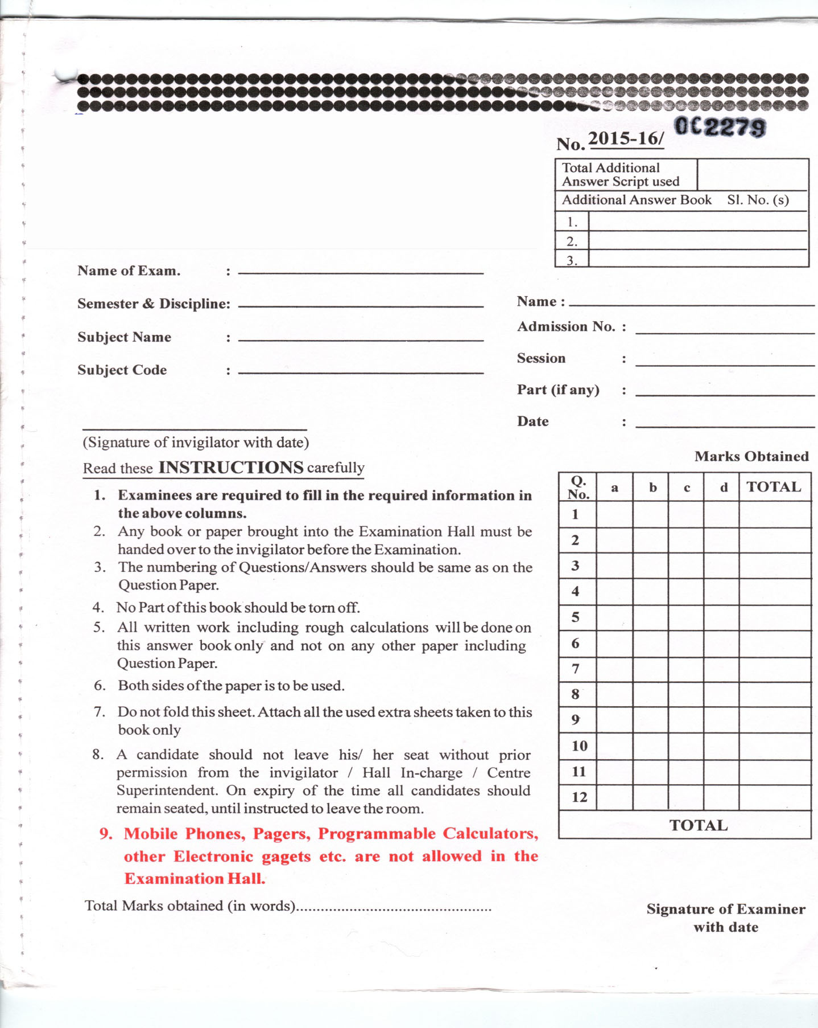

**Hkkjrh; izkS|ksfxdh laLFkku**

**¼Hkkjrh; [kfu fo|kihB½] /kuckn**

**INDIAN INSTITUTE OF TECHNOLOGY**

**(INDIAN SCHOOL OF MINES), DHANBAD**

**Annexure-III**

**ABOVE TERMS AND CONDITIONS OF THE NIT ARE ACCEPTED**

|  |  |  |
| --- | --- | --- |
| 1 | Name and address of the tenderer |  |
| 2 | Telecom nos. of the tenderer i.e. phone  fax, & email id. |  |
| 3 | Signature, name & designation of the person signing on behalf of the tenderer & his/her office seal |  |
| 4. | Name & designation of the contact person & his phone/mobile no. |  |

**Annexure-IV**

#### 

**FORMAT OF BANK GUARANTEE TOWARDS BID SECURITY**

**(EARNEST MONEY DEPOSITE)**

Reference. : NIT. No. ________________________________ dated ___________

Dear Sir,

GUARANTEE NO. ________________________ date : ___________

AMOUNT OF GUARANTEE Rs. ____________

GUARANTEE COVERS FROM _________________ TO ______________

LAST DATE FOR LODGEMENT OF CLAIM : _________________

Whereas____________(hereinafter called “the Bidder”) has submitted its bid dated ___________

(date of submission of bid) for the supply of ……………………………………………………… (name and/or description of the goods) (hereinafter called “the Bid”) against Notice Inviting Tender (Tender Document) No.___________dated ____________ of the Indian Institute of Technology (Indian School of Mines), Dhanbad.

KNOW ALL PEOPLE by these presents that WE ____________________________________ (name of bank) of _________________ (name of country), having our registered office at ___________________________________________________________________ (address of bank) (hereinafter called “the Bank”), are bound unto ______________________________________ (name of Purchaser) (hereinafter called “the Purchaser”) in the sum of ___________________ for which payment will and truly to be made to the said Purchaser, the Bank binds itself, its successors, and assigns by these presents. Sealed with the Common Seal of the said Bank this ______ day of ________ (year).

THE CONDITIONS of this obligation are:

1) If the Bidder withdraws its Bid during the period of bid validity specified by the Bidder on the Bid Form; or

2) If the Bidder, having been notified of the acceptance of its bid by the Purchaser during the period of bid validity:

(a) fails or refuses to execute the Contract Form if required; or

(b) fails or refuses to furnish the performance security, in accordance with the Instruction to Bidders;

We undertake to pay the Purchaser up to the above amount upon receipt of its first written demand, without the Purchaser having to substantiate its demand, provided that in its demand the Purchaser will note that the amount claimed by it is due to it, owing to the occurrence of one or both of the two conditions, specifying the occurred condition or conditions.

This guarantee will remain in force up to Eight Months from the date of opening of tender or the period of the bid validity whichever is later and any demand in respect thereof should reach the Bank not later than the above date.

**Details of the Issuing Bank**

|  |  |
| --- | --- |
| Name of the Bank |  |
| Branch Name |  |
| Branch Code |  |
| IFSC Code |  |
| E-mail Id |  |
| Phone/Mobile No. |  |

**Seal & Signature of the Bank**

**Annexure-V**

**Compliance Statement**

|  |  |  |  |
| --- | --- | --- | --- |
| **Sl. No** | **Technical requirement as per**  **NIT** | **What is offered by the tenderer** | **Status of Compliance**  **Complied/Not Complied** |

***Annexure - VI***

**Format for Financial Bid**

NIT No.: INST-500276-17-18 Date:

Bidders Ref: No. Date:

GSTIN No.:

**Subject: Printing & Supply of Semester Answer Book**

|  |  |  |  |  |
| --- | --- | --- | --- | --- |
| Sl. No. | Full Description of Items with (HSN Code/SAC Code) | Qty. | Rate | Amount |
|  |  |  |  |  |
|  |  |  |  |  |
|  |  | Packing & Forwarding (if any) | |  |
|  |  | **Total** | |  |
|  |  | GST | |  |
|  |  | Freight (if any) | |  |
|  |  | Installation (if any) | |  |
| Amount should be in figure as well as word | | **Grand Total** | |  |

**Note:**

1) All the details must be provided as per prescribed format only

2) Prices quoted by the bidders should include GST, HSN Code, SAC Code, duties, livies, transportation cost

and insurance costs etc. if any

3) All the rates must be quoted in Indian Rupees.